# CS 250 HW1 report2

## 1:

Result1(don’t free):

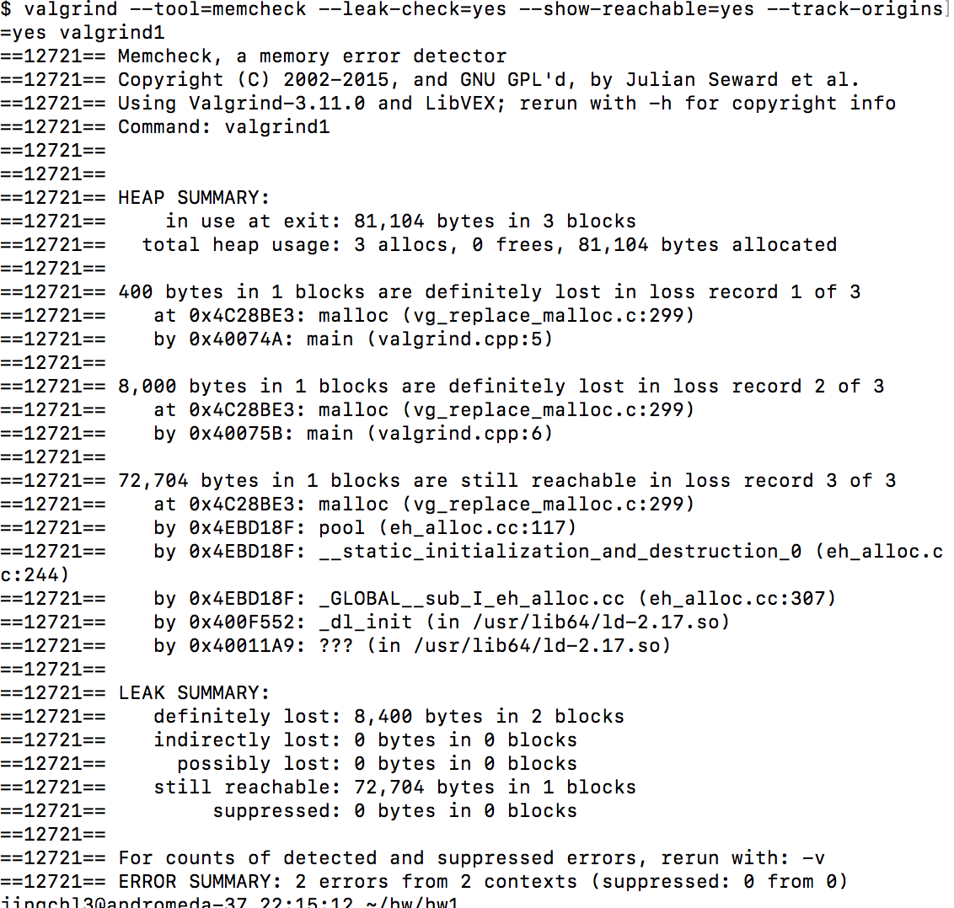

Result2(free):

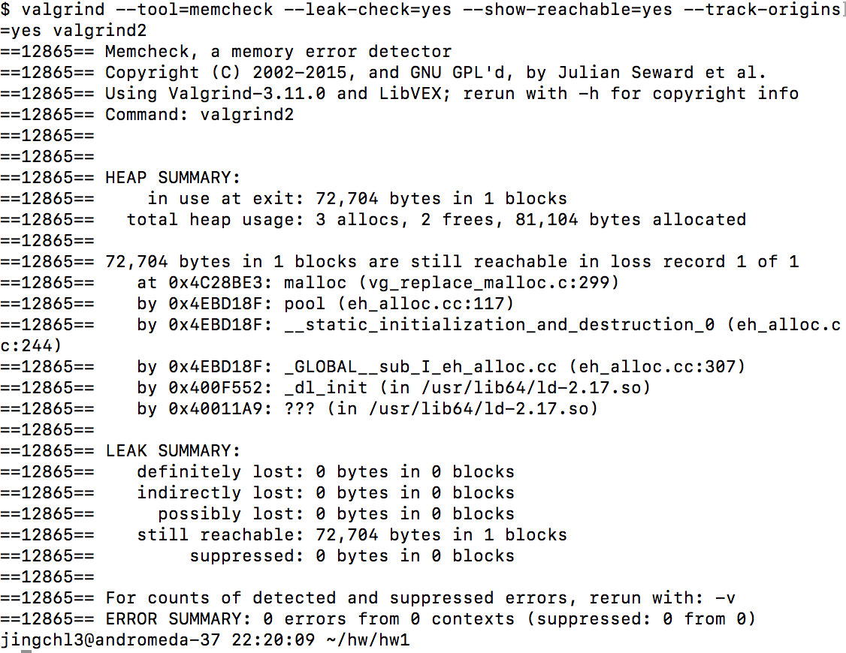

1. Do you see any memory leak in either or both scenarios?

In the first result which doesn’t free the pointer, there are memory leak; There is no memory leak in the other one that frees the pointer.

1. How much memory leak did you see?

There are 8400 Bytes memory leak in the first result.

1. Does the memory leak match with your allocations?

The size of memory leak is just the same with the size of I allocated.

## 2:

Result3(exceed the array size limit)

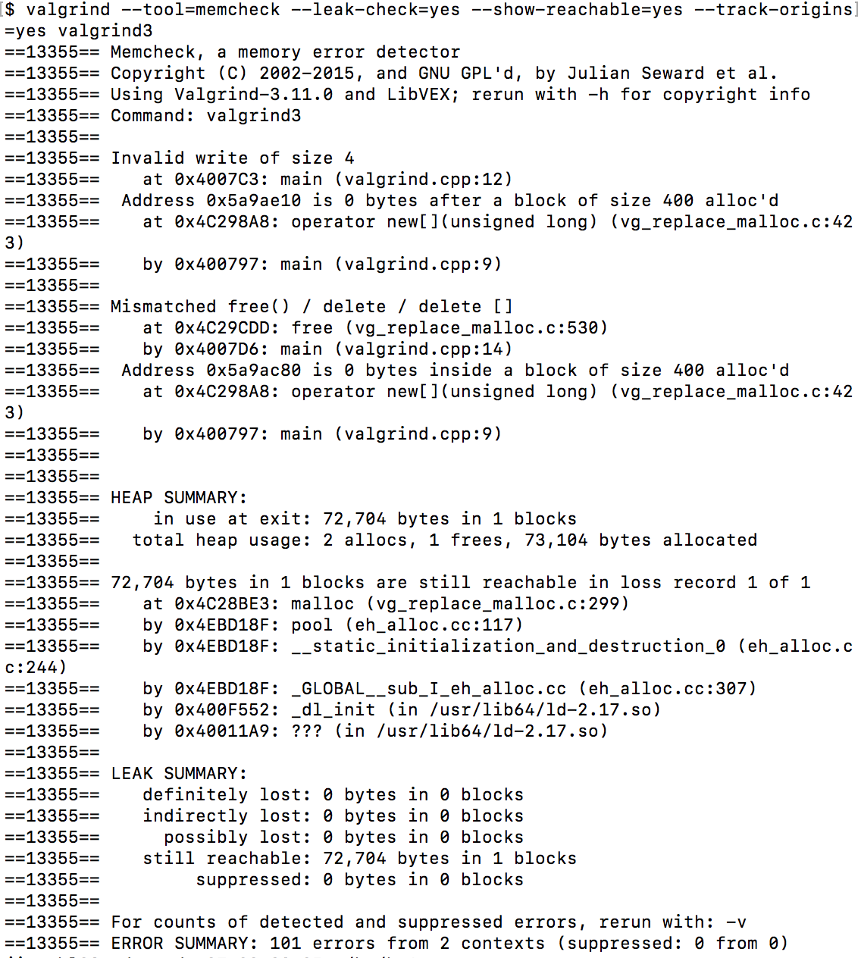

1. What is the valgrind output?

The result is above.

1. Can you run the program without any errors?

No, there are errors when I run it.

1. Try to increase the size of the iteration until you get a segfault. What happens when you run it independently and with valgrind?

When I the size of the iteration is 200000, it has segfault.

When I run it independently, it shows “Segmentation fault (core dumped)”;

When I run it with valgrind, it doesn’t show “Segmentation fault (core dumped)” error, but it’s Error summary shows the number of wrong allocations.

